**Introduction to SQL**

LAB EXERCISES:

**Lab 1: Create a new database named school_db and a table called students with the following columns: student_id, student_name, age, class, and address.**

**Lab 2: Insert five records into the students table and retrieve all records using the SELECT statement.**

Command:

CREATE DATABASE school_db;

CREATE TABLE students(student_id int, student_name varchar(30), age int , class int , address text);

[SELECT](http://localhost/phpmyadmin/url.php?url=https://dev.mysql.com/doc/refman/8.0/en/select.html)  *FROM `student` ;

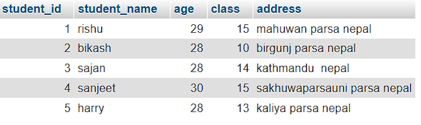

**2. SQL Syntax**

LAB EXERCISES:

**• Lab 1: Write SQL queries to retrieve specific columns (student_name and age) from the students table.**

**• Lab 2: Write SQL queries to retrieve all students whose age is greater than 10**.

Command:

[SELECT](http://localhost/phpmyadmin/url.php?url=https://dev.mysql.com/doc/refman/8.0/en/select.html) student_name,age FROM `student`;

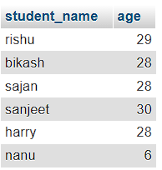

Command:

[SELECT](http://localhost/phpmyadmin/url.php?url=https://dev.mysql.com/doc/refman/8.0/en/select.html)  *FROM `student` WHERE age>10;

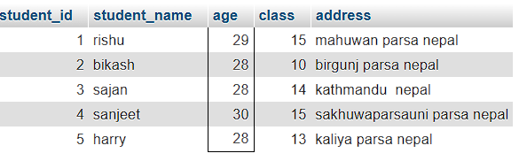

**3. SQL Constraints**

LAB EXERCISES:

**• Lab 1: Create a table teachers with the following columns: teacher_id (Primary Key), teacher_name (NOT NULL), subject (NOT NULL), and email (UNIQUE).**

**• Lab 2: Implement a FOREIGN KEY constraint to relate the teacher_id from the teachers table with the students table.**

Command:

CREATE TABLE teachers

(

teacher_id int (Primary Key),

teacher_name varchar (NOT NULL),

subject varchar (NOT NULL),

email text (UNIQUE)

),



Command:

CREATE TABLE students(

student_id int PRIMARY KEY,

student_name varchar(30),

age int , class int ,

address text,

teacher_id int,

FOREIGN KEY(teacher_id) REFERENCES students(teacher_id)

);



**4. Main SQL Commands and Sub-commands (DDL)**

LAB EXERCISES:

**• Lab 1: Create a table courses with columns: course_id, course_name, and course_credits. Set the course_id as the primary key.**

**• Lab 2: Use the CREATE command to create a database university_db.**

**Command:**

CREATE DATABASE university_db;

CREATE TABLE courses(

course_id int PRIMARY KEY,

course_name varchar(30),

course_credits int

);



**5. ALTER Command**

LAB EXERCISES:

**• Lab 1: Modify the courses table by adding a column course_duration using the ALTER command.**

**• Lab 2: Drop the course_credits column from the courses table.**

**Command:**

ALTER TABLE courses add course_duration int;



**Command:**

ALTER TABLE courses DROP COLUMN course_credits;



**6. DROP Command**

LAB EXERCISES:

**• Lab 1: Drop the teachers table from the school_db database.**

**• Lab 2: Drop the students table from the school_db database and verify that the table has been removed.**

**Command:**

DROP TABLE students;

DROP TABLE TEACHERS;

**7. Data Manipulation Language (DML)**

LAB EXERCISES:

**• Lab 1: Insert three records into the courses table using the INSERT command.**

**• Lab 2: Update the course duration of a specific course using the UPDATE command.**

**• Lab 3: Delete a course with a specific course_id from the courses table using the DELETE command.**

**Command:**

INSERT INTO courses VALUES(

101,'python','6 month'),

(102,'C++','12 month'),

(103,'Java','8 month');

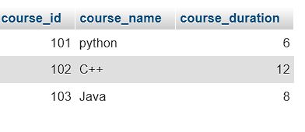

**Command:**

UPDATE courses SET course_duration=4 WHERE course_name=’python’;

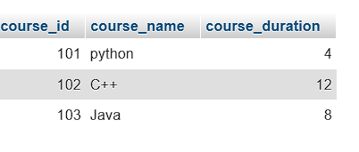

**Command:**

DELETE FROM courses WHERE course_id=102;

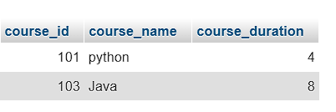

**8. Data Query Language (DQL)**

LAB EXERCISES:

**• Lab 1: Retrieve all courses from the courses table using the SELECT statement.**

**• Lab 2: Sort the courses based on course_duration in descending order using ORDER BY.**

**• Lab 3: Limit the results of the SELECT query to show only the top two courses using LIMIT.**

**Command:**

[SELECT](http://localhost/phpmyadmin/url.php?url=https://dev.mysql.com/doc/refman/8.0/en/select.html) * FROM courses;

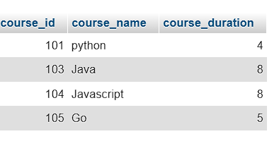

**Command:**

[SELECT](http://localhost/phpmyadmin/url.php?url=https://dev.mysql.com/doc/refman/8.0/en/select.html) * FROM `courses` ORDER BY course_duration;

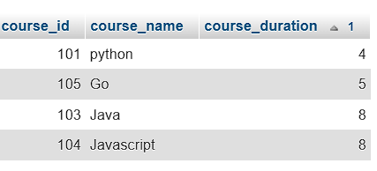

**Command:**

[SELECT](http://localhost/phpmyadmin/url.php?url=https://dev.mysql.com/doc/refman/8.0/en/select.html) * FROM `courses` LIMIT 2;

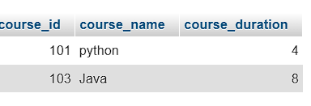

**11. SQL Joins**

LAB EXERCISES:

**• Lab 1: Create two tables: departments and employees. Perform an INNER JOIN to display employees along with their respective departments.**

**• Lab 2: Use a LEFT JOIN to show all departments, even those without employees.**

**Command:**

[SELECT](http://localhost/phpmyadmin/url.php?url=https://dev.mysql.com/doc/refman/8.0/en/select.html) emp_id,emp_name,dep_name FROM employees INNER JOIN departments ON employees.dep_id=departments.dep_id;

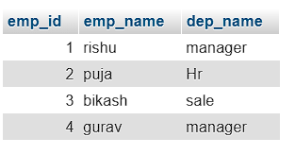

**Command:**

[SELECT](http://localhost/phpmyadmin/url.php?url=https://dev.mysql.com/doc/refman/8.0/en/select.html) dep_name,emp_id,emp_name FROM departments [LEFT](http://localhost/phpmyadmin/url.php?url=https://dev.mysql.com/doc/refman/8.0/en/string-functions.html%23function_left) JOIN employees ON employees.dep_id=departments.dep_id;

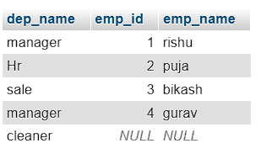

**12. SQL Group By**

LAB EXERCISES:

**• Lab 1: Group employees by department and count the number of employees in each department using GROUP BY.**

**• Lab 2: Use the AVG aggregate function to find the average salary of employees in each department.**

**Command:**

[SELECT](http://localhost/phpmyadmin/url.php?url=https://dev.mysql.com/doc/refman/8.0/en/select.html) dep_id, [COUNT](http://localhost/phpmyadmin/url.php?url=https://dev.mysql.com/doc/refman/8.0/en/aggregate-functions.html%23function_count)(*) AS emp_id FROM employees GROUP by dep_id;

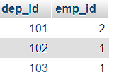

**Command:**

[SELECT](http://localhost/phpmyadmin/url.php?url=https://dev.mysql.com/doc/refman/8.0/en/select.html) dep_id, [AVG](http://localhost/phpmyadmin/url.php?url=https://dev.mysql.com/doc/refman/8.0/en/aggregate-functions.html%23function_avg)(emp_salary) AS emp_salary FROM employees GROUP by dep_id;

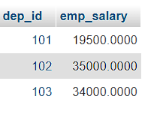

**13. SQL Stored Procedure**

LAB EXERCISES:

**• Lab 1: Write a stored procedure to retrieve all employees from the employees table based on department.**

**• Lab 2: Write a stored procedure that accepts course_id as input and returns the course details.**

**Command:**

DELIMITER $$

CREATE PROCEDURE GetEmployeesByDepartment(IN dep_id INT)

BEGIN

SELECT

emp_id,

emp_name,

emp_gander,

emp_salary,

dep_id

FROM

employees

WHERE

dep_id = dept_id;

END $$

DELIMITER ;

CALL GetEmployeesByDepartment(2)

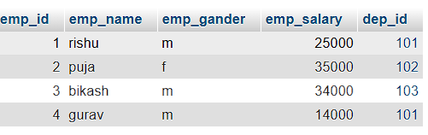

**Command:**

CREATE PROCEDURE GetCourseDetails(IN input_course_id INT)

BEGIN

SELECT

course_id,

course_name,

course_duration

FROM

courses

WHERE

course_id = input_course_id;

END $$

DELIMITER ;

[CALL](http://localhost/phpmyadmin/url.php?url=https://dev.mysql.com/doc/refman/8.0/en/call.html) GetCourseDetails(101);

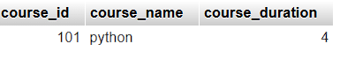

**14. SQL View**

LAB EXERCISES:

**• Lab 1: Create a view to show all employees along with their department names.**

**• Lab 2: Modify the view to exclude employees whose salaries are below $50,000.**

**Command:**

CREATE VIEW EmployeeDepartmentView AS

SELECT

e.emp_id,

e.emp_name,

e.emp_gander,

e.emp_salary,

d.dep_id,

d.dep_name

FROM

employees e

JOIN

departments d

ON

e.dep_id = d.dep_id;

[SELECT](http://localhost/phpmyadmin/url.php?url=https://dev.mysql.com/doc/refman/8.0/en/select.html) * FROM EmployeeDepartmentView;

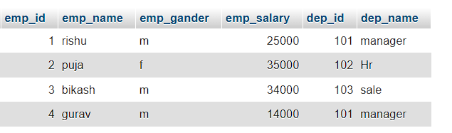

**Command:**

CREATE OR REPLACE VIEW EmployeeDepartmentView AS

SELECT

e.emp_id,

e.emp_name,

e.emp_gander,

e.emp_salary,

d.dep_id,

d.dep_name

FROM

employees e

JOIN

departments d

ON

e.dep_id = d.dep_id

WHERE

e.emp_salary >= 34000;

[SELECT](http://localhost/phpmyadmin/url.php?url=https://dev.mysql.com/doc/refman/8.0/en/select.html) * FROM EmployeeDepartmentView;

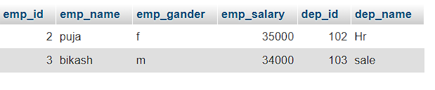

**15. SQL Triggers**

LAB EXERCISES:

**• Lab 1: Create a trigger to automatically log changes to the employees table when a new employee is added.**

**• Lab 2: Create a trigger to update the last_modified timestamp whenever an employee record is updated.**

**Command:**

[CREATE](http://localhost/phpmyadmin/url.php?url=https://dev.mysql.com/doc/refman/8.0/en/create-table.html) [TABLE](http://localhost/phpmyadmin/url.php?url=https://dev.mysql.com/doc/refman/8.0/en/create-table.html) employee_changes_log ( log_id INT AUTO_INCREMENT PRIMARY KEY, employee_id INT [NOT](http://localhost/phpmyadmin/url.php?url=https://dev.mysql.com/doc/refman/8.0/en/logical-operators.html%23operator_not) NULL, change_type VARCHAR(50) [NOT](http://localhost/phpmyadmin/url.php?url=https://dev.mysql.com/doc/refman/8.0/en/logical-operators.html%23operator_not) NULL, change_date TIMESTAMP [DEFAULT](http://localhost/phpmyadmin/url.php?url=https://dev.mysql.com/doc/refman/8.0/en/miscellaneous-functions.html%23function_default) [CURRENT_TIMESTAMP](http://localhost/phpmyadmin/url.php?url=https://dev.mysql.com/doc/refman/8.0/en/date-and-time-functions.html%23function_current_timestamp), details TEXT );

DELIMITER $$

CREATE TRIGGER after_employee_insert

AFTER INSERT ON employees

FOR EACH ROW

BEGIN

INSERT INTO employee_changes_log (

employee_id,

change_type,

details

)

VALUES (

NEW.emp_id,

'INSERT',

CONCAT('New employee added: ', NEW.emp_name, ' ',

', Department ID: ', NEW.dep_id,

', Salary: $', NEW.emp_salary)

);

END $$

DELIMITER ;

INSERT INTO employees (emp_id, emp_name, dep_id, emp_salary) VALUES (4, 'John', 101, 60000);



[ALTER](http://localhost/phpmyadmin/url.php?url=https://dev.mysql.com/doc/refman/8.0/en/alter-table.html) [TABLE](http://localhost/phpmyadmin/url.php?url=https://dev.mysql.com/doc/refman/8.0/en/alter-table.html) employees ADD COLUMN last_modified TIMESTAMP [DEFAULT](http://localhost/phpmyadmin/url.php?url=https://dev.mysql.com/doc/refman/8.0/en/miscellaneous-functions.html%23function_default) [CURRENT_TIMESTAMP](http://localhost/phpmyadmin/url.php?url=https://dev.mysql.com/doc/refman/8.0/en/date-and-time-functions.html%23function_current_timestamp) ON [UPDATE](http://localhost/phpmyadmin/url.php?url=https://dev.mysql.com/doc/refman/8.0/en/update.html) [CURRENT_TIMESTAMP](http://localhost/phpmyadmin/url.php?url=https://dev.mysql.com/doc/refman/8.0/en/date-and-time-functions.html%23function_current_timestamp);

DELIMITER $$

CREATE TRIGGER before_employee_update

BEFORE UPDATE ON employees

FOR EACH ROW

BEGIN

SET NEW.last_modified = CURRENT_TIMESTAMP;

END $$

DELIMITER ;

UPDATE employees

SET emp_salary = 65000

WHERE emp_id = 5;

